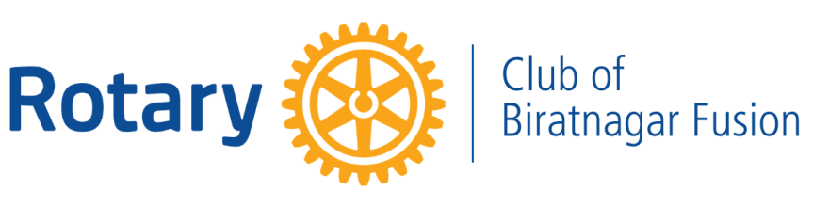 SERVICE PROJECT REPORT

FREE DENTAL CHECKUP CAMP
Promoting Preventive Oral Healthcare in the Community
DATE  17 September 2026 | LOCATION  Budiganga Gaupalika, Morang | ROTARY YEAR  2026–27
AREA OF FOCUS  Disease Prevention and Treatment | COLLABORATION  Naulakha Dental Care | PROJECT COST  NPR 4,000

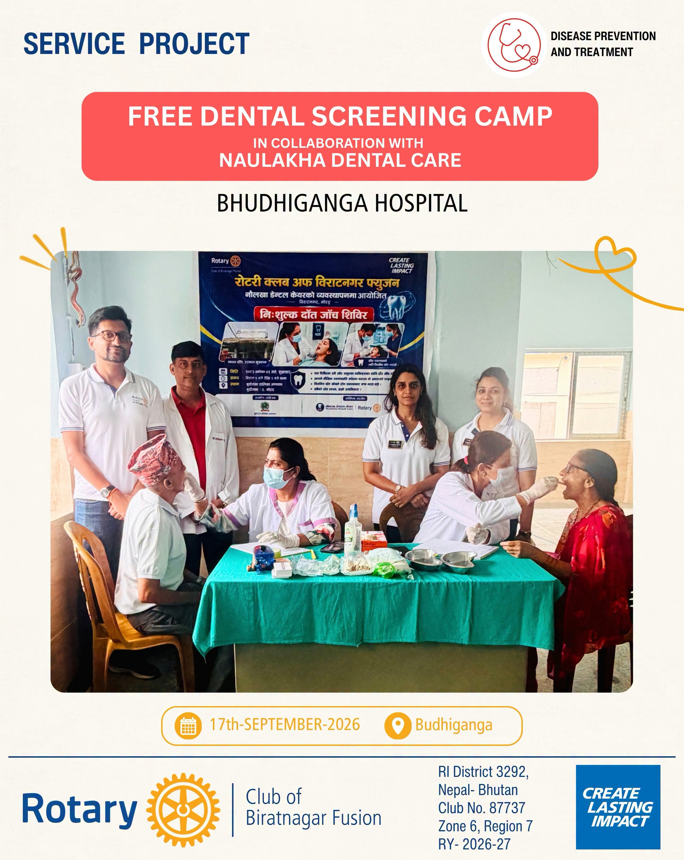

Project Overview
Rotary Club of Biratnagar Fusion organized a Free Dental Checkup Camp in collaboration with Naulakha Dental Care at Budiganga Gaupalika, Morang, with the objective of making essential dental healthcare more accessible to the local community. The initiative combined free dental screening with oral-health awareness, focusing on preventive care, early identification of dental problems and encouraging beneficiaries to seek timely professional treatment.

Project at a Glance
7  Wards Covered | 90  Beneficiaries Screened | NPR 4,000  Project Cost

Objective
The project aimed to promote preventive oral healthcare by providing accessible dental examinations to community members, identifying oral-health concerns at an early stage, creating awareness about proper oral hygiene and encouraging timely treatment wherever required.

Project Implementation
The programme extended its outreach across 7 wards of Budiganga Gaupalika. To strengthen community outreach prior to the camp, awareness was also carried out through miking using an e-rickshaw across the targeted areas, informing residents about the free dental camp and encouraging them to avail themselves of the screening facility.
With professional support from the dental team of Naulakha Dental Care, beneficiaries received free dental examinations and guidance regarding their oral-health concerns. The medical team assessed patients for common dental problems and advised them on preventive measures and the need for further treatment wherever required. Rotary members supported the initiative through coordination, community outreach and on-ground management, helping ensure smooth implementation of the camp.

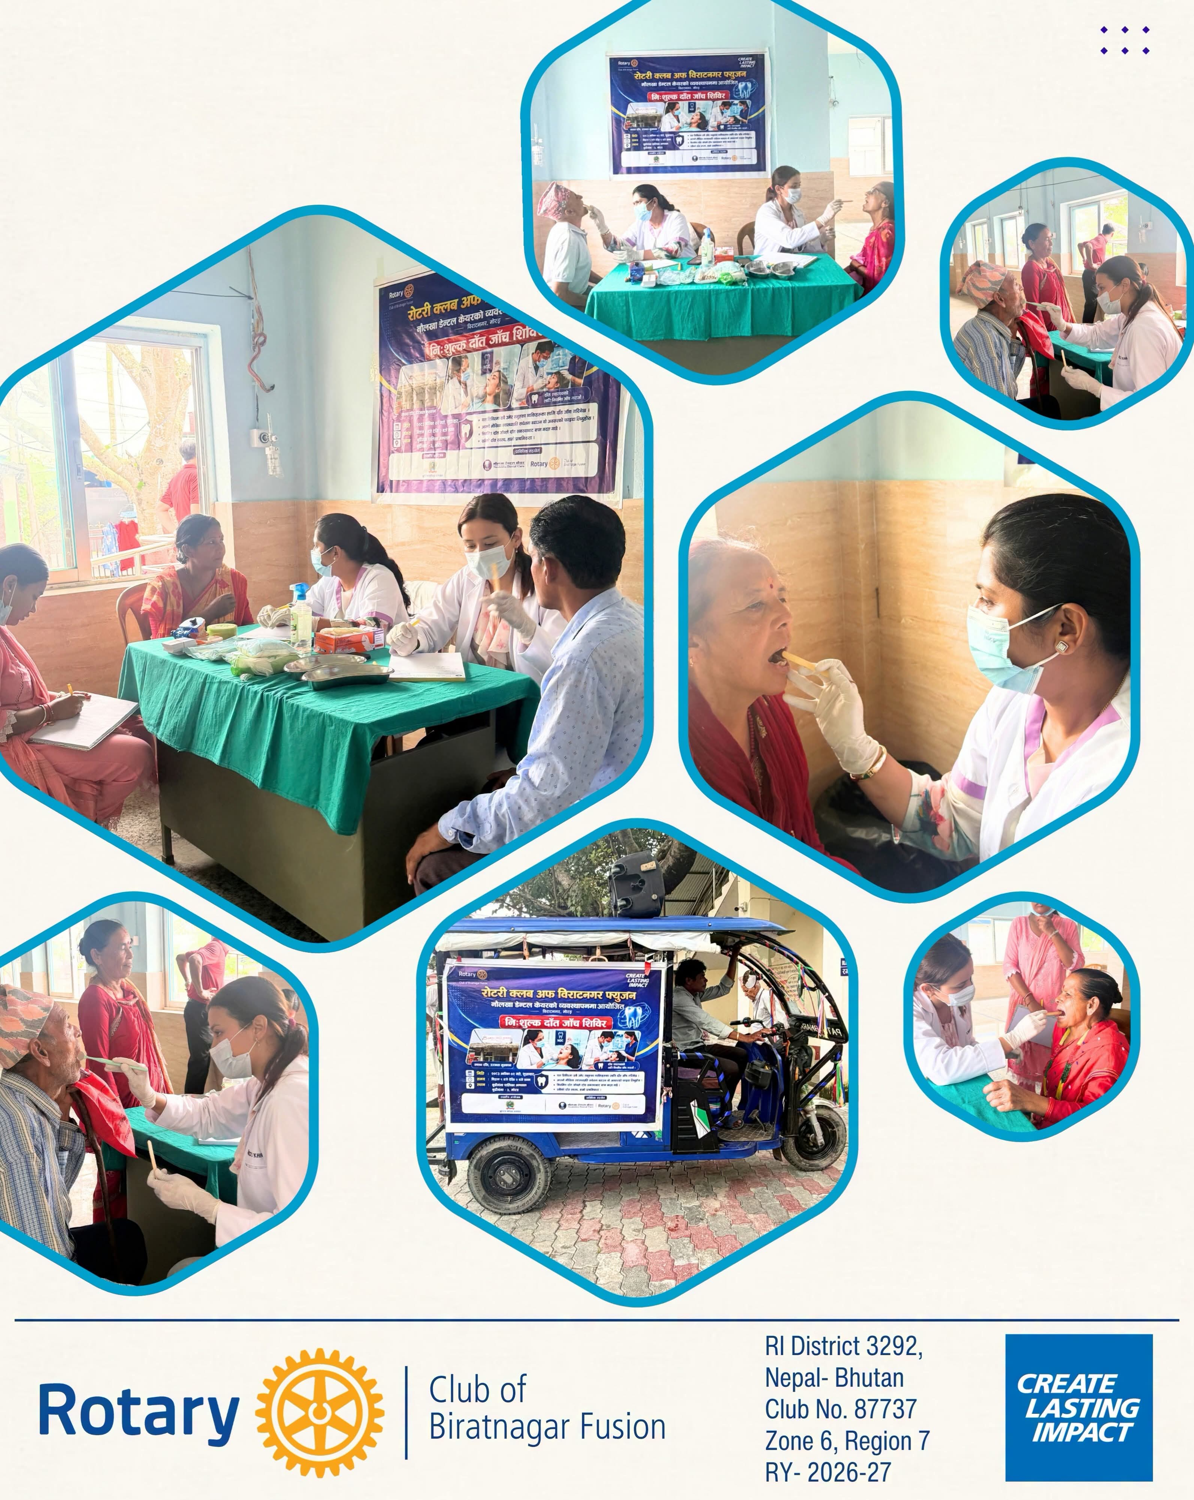

Beneficiary Profile
The project benefited residents from across 7 wards of Budiganga Gaupalika, Morang. A total of 90 individuals received free dental screening, giving them access to professional assessment and guidance regarding their oral health and any further treatment that might be required.

Impact & Outcome
AWARENESS → SCREENING → EARLY INTERVENTION
Through the camp, 90 beneficiaries gained access to professional dental examination, while the wider initiative reinforced the importance of oral hygiene, regular dental checkups and preventive care. Beyond identifying immediate dental concerns, the programme encouraged beneficiaries to consider oral health an integral part of overall well-being and to seek professional assistance before minor dental problems develop into more serious conditions.

Collaboration for Community Health
The initiative demonstrated the value of collaboration between Rotary Club of Biratnagar Fusion and Naulakha Dental Care, bringing together Rotary's community outreach and professional dental expertise. This partnership enabled the club to translate health awareness into direct, accessible and meaningful community service.

Conclusion
The Free Dental Checkup Camp was a meaningful preventive-healthcare initiative undertaken by Rotary Club of Biratnagar Fusion during RY 2026–27. With 7 wards covered and 90 beneficiaries screened, the project combined accessible dental care with awareness, prevention and early identification of oral-health concerns. Through this initiative, Rotary Club of Biratnagar Fusion continued its commitment to accessible healthcare, preventive intervention and sustainable community well-being — creating lasting impact through service.

Prepared by:
Rtn. Aparna Nathani Sharda
Secretary
Rotary Club of Biratnagar Fusion
RY 2026–27

