
SERVICE PROJECT REPORT

SCHOOL SHOES DISTRIBUTION PROGRAMME
Supporting Education | Supporting Children | Strengthening Community
DATE  22 September 2026 | LOCATION  Biratnagar-10, Tintoliya, Morang | ROTARY YEAR  2026-27
AREA OF FOCUS  Child Development | COLLABORATION  NYEF, Biratnagar Chapter | SPONSERSHIP VALUE  NPR 17,000
PHOTO PLACEHOLDER
Insert your FINAL SCHOOL SHOES DISTRIBUTION COLLAGE here

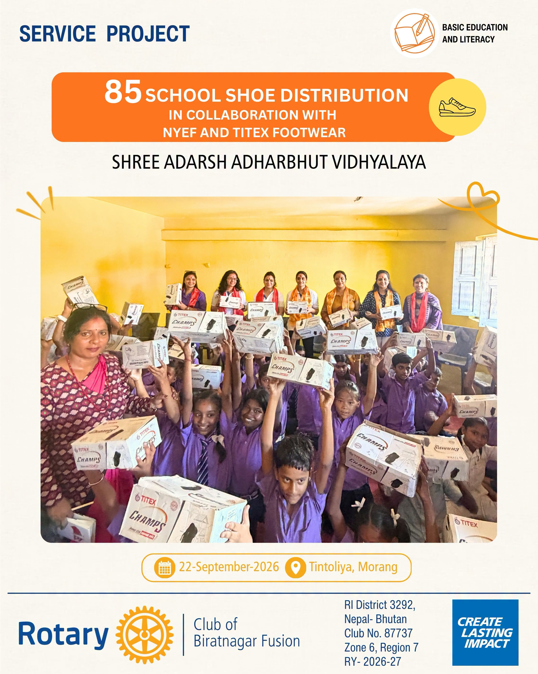

Project Overview
Rotary Club of Biratnagar Fusion, in collaboration with NYEF, Biratnagar Chapter, organized a School Shoes Distribution Programme at Shree Adarsh Aadharbhut Vidhyalaya, Biratnagar-10, Tintoliya, Morang. The initiative was undertaken in support of the Biratnagar Kora Cycle Race 2026 and focused on providing a basic school necessity to children while strengthening Rotary's engagement with the local community. A total of 85 pairs of school shoes, valued at NPR 17,000, were distributed to 85 students.

Project at a Glance
85  Students Benefited | 85  Pairs of Shoes Distributed | NPR 17,000  Project Value
The 85 pairs of school shoes were sponsored by Charter President Rtn. Rajat Todi and his wife, Past President Rtn. Shweta Todi, through Titex Shoes.

Objective
The project aimed to support school-going children by providing them with a practical and essential requirement for their everyday school life. Beyond the distribution itself, the initiative sought to promote child welfare, dignity and educational support while bringing Rotary, NYEF, the school and community representatives together through meaningful service.

Project Implementation
The distribution programme was conducted at Shree Adarsh Aadharbhut Vidhyalaya with the participation of Rotary Club of Biratnagar Fusion members, NYEF Biratnagar Chapter members, school representatives and local community leadership. Eighty-five identified students received new pairs of school shoes, ensuring that the support reached the intended beneficiaries directly.
The programme was carried out in an organized and engaging manner, allowing Rotary members and collaborating partners to interact with the school community while distributing the shoes.

Impact & Outcome
NEED -> SUPPORT -> DIGNITY -> EDUCATION
The project successfully provided 85 pairs of school shoes to 85 students, addressing a simple but meaningful requirement in their everyday school life. The initiative also strengthened collaboration between Rotary Club of Biratnagar Fusion, NYEF Biratnagar Chapter, the school and community representatives, demonstrating how collective participation can translate into practical support for children.
The programme further carried forward the service impact associated with the Biratnagar Kora Cycle Race 2026, converting community participation into a tangible initiative for students.
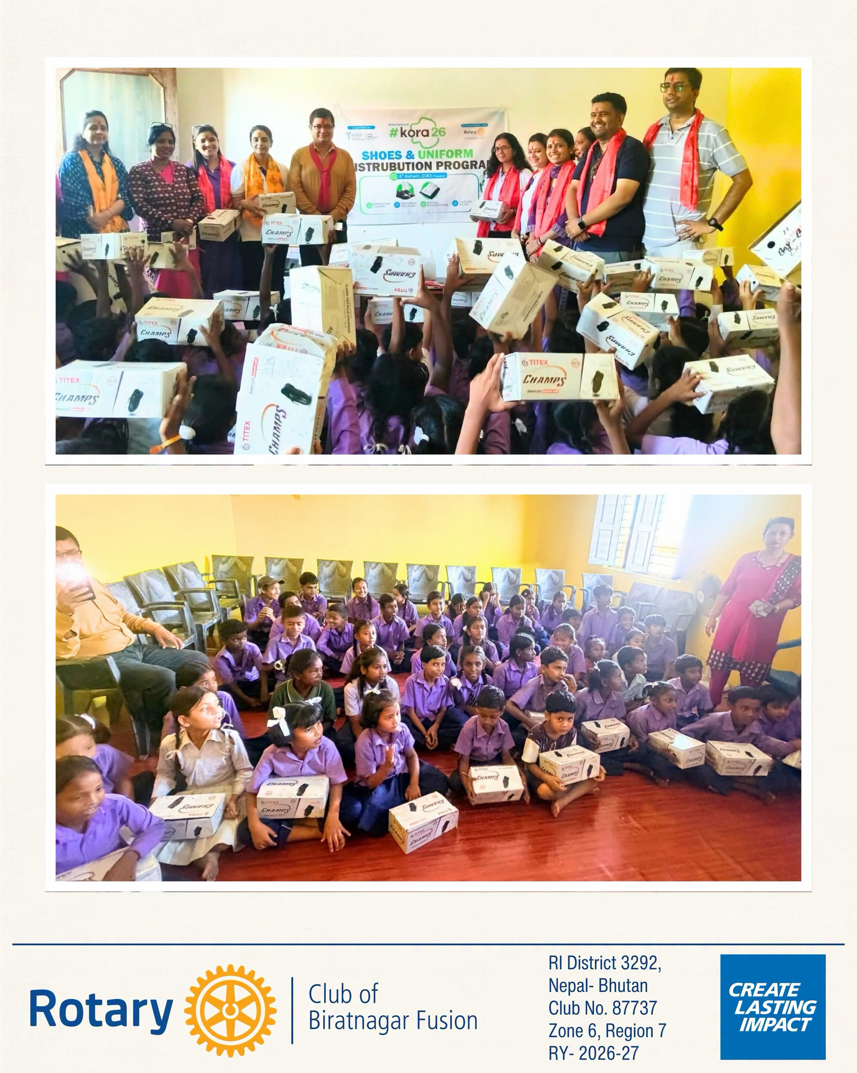

Acknowledgement
Rotary Club of Biratnagar Fusion gratefully acknowledges Charter President Rtn. Rajat Todi and Past President Rtn. Shweta Todi for sponsoring the 85 pairs of school shoes through Titex Shoes. The Club also appreciates NYEF, Biratnagar Chapter, the school principal and staff, and everyone involved in coordinating and successfully conducting the programme.

Conclusion
The School Shoes Distribution Programme reflected Rotary Club of Biratnagar Fusion's commitment to supporting children through practical, need-based community service. With 85 students directly benefited, the initiative went beyond the distribution of school shoes - it represented care, dignity and collective responsibility toward the younger members of the community.
85 STUDENTS | 85 PAIRS OF SHOES | ONE MEANINGFUL STEP FORWARD
Prepared by:
Rtn. Aparna Nathani Sharda
Secretary
Rotary Club of Biratnagar Fusion
RY 2026-27

